**RASPBERRY PI 3**

 The Raspberry Pi 3 Model B+ is the latest product in the Raspberry Pi 3 range, boasting a 64-bit quad core processor running at 1.4GHz, dual-band 2.4GHz and 5GHz wireless LAN, bluetooth 4.2/BLE, faster Ethernet, and PoE capability via a separate PoE HAT.  
- The dual-band wireless LAN comes with modular compliance certification, allowing the board to be designed into end products with significantly reduced, wireless LAN compliance testing, improving both cost and time to market.  
- The Raspberry Pi 3 Model B+ maintains the same mechanical footprint as both the Raspberry Pi 2 Model B and the Raspberry Pi 3 Model B.

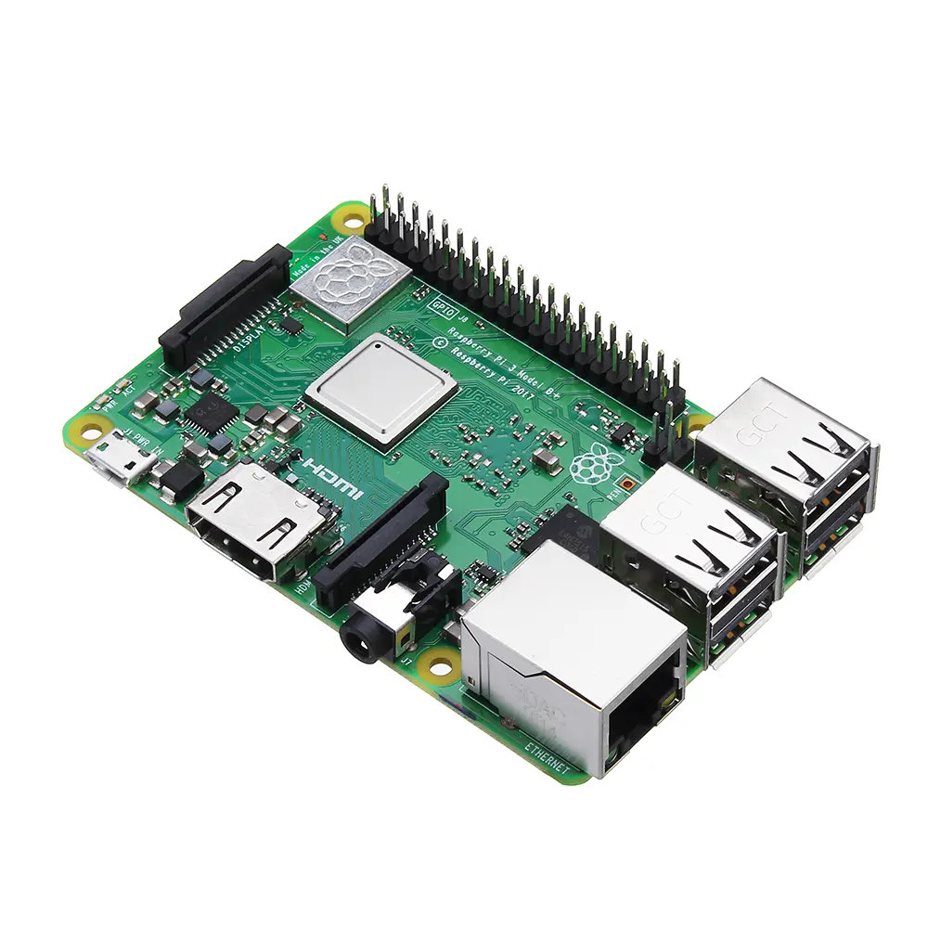

1. **Specifications**

**- Processor:** Broadcom BCM2837B0, Quad-Core Cortex-A53 (ARMv8) 64-bit SoC @ 1.4GHz **Clockspeed**  
**- Memory:** 1GB LPDDR2 SDRAM  
**- Connectivity:**  
1. 2.4GHz and 5GHz IEEE 802.11.b/g/n/ac wireless LAN, Bluetooth 4.2, BLE  
2. Gigabit Ethernet over USB 2.0 (maximum throughput 300 Mbps)  
3. 4 USB 2.0 ports with up to 1.2A output  
**- Access:** Extended 40-pin GPIO header  
**- Video & sound:**  
 1. Full-size HDMI  
2. CSI camera port for connecting a Raspberry Pi camera  
3. DSI display port for connecting a Raspberry Pi touchscreen display  
4. 4-pole stereo output and composite video port  
**- Multimedia:** H.264, MPEG-4 decode(1080p30); H.264 encode(1080p30); OpenGL ES 1.1,2.0 graphics  
**- SD card support:** Micro SD port for loading your operating system and storing data  
**- Input power:**  
1. 5V/2.5A DC power input  
2. 5V DC via GPIO header  
3. Power-over-Ethernet (PoE) support (requires separate PoE HAT)  
**- Environment:** Operating temperature, 0-50°C

1. **Pin-out diagram**

A Raspberry Pi 3 board has 40 pins on it. Among these pins, we have four power pins on the Raspberry Pi, two of which are 5v pins and another two are 3.3v pins. The 5v power pins are connected directly to the Raspberry Pi's power input and we can use these pins to run low power applications.

Then there are the ground pins. There are eight ground pins and all of these are connected to each other; you can use any of these ground pins for your projects. That leaves us with 28 GPIO pins, labeled starting from GPIO 0 and going up to GPIO 27

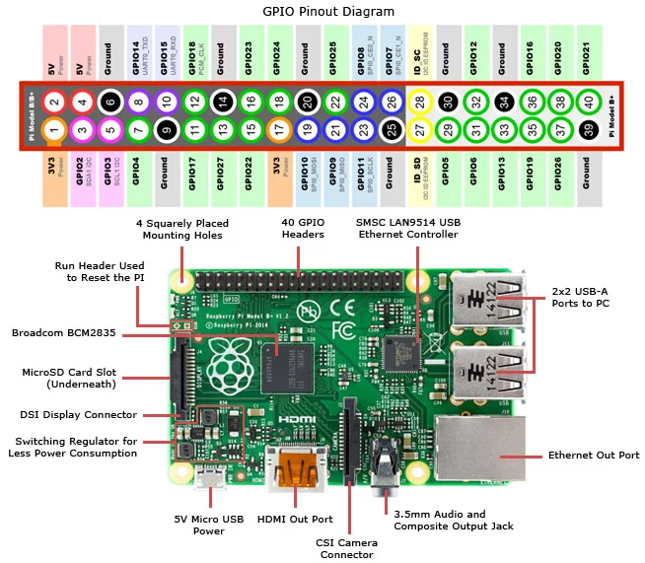

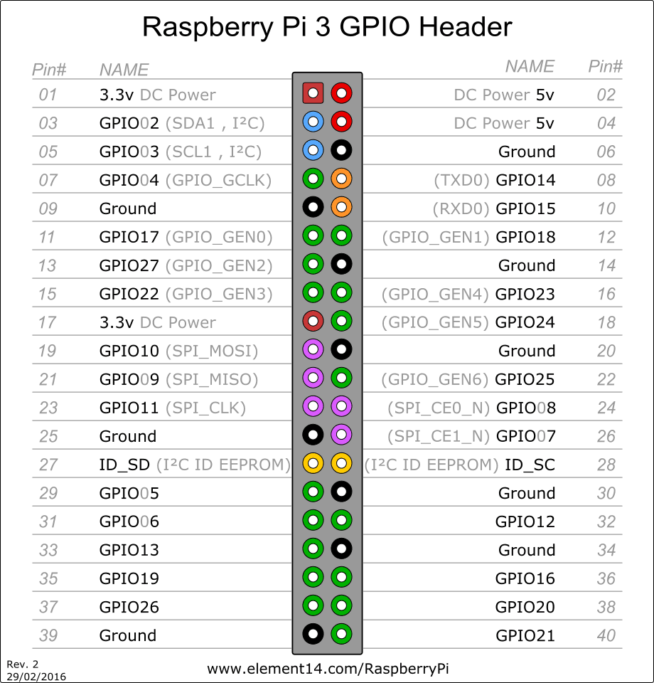

1. **Communication**

The Raspberry Pi 3 Model B+ offers a rich variety of communication interfaces that make it suitable for a wide range of embedded and IoT applications, including satellite system prototypes. One of the most significant communication features is the **40-pin GPIO (General Purpose Input/Output) header**, which supports multiple serial protocols. It includes dedicated pins for **UART (Universal Asynchronous Receiver/Transmitter)** used for serial communication with modules like GPS, GSM, and debug consoles. The board also supports **I²C (Inter-Integrated Circuit)** and **SPI (Serial Peripheral Interface)**, which are essential for communicating with sensors, memory chips, real-time clocks, and other microcontrollers. These protocols enable the Raspberry Pi to gather and transmit data from various onboard or external devices efficiently.

In terms of wireless communication, the Raspberry Pi 3 Model B+ is equipped with **dual-band Wi-Fi (2.4 GHz and 5 GHz)** that adheres to the 802.11 b/g/n/ac standards. This makes it possible to connect the Pi to wireless networks for internet access or to other devices over a LAN. The Wi-Fi capability is particularly valuable for sending telemetry data or remotely monitoring systems during satellite ground testing or lab simulations. Additionally, the board supports **Bluetooth 4.2 and Bluetooth Low Energy (BLE)**. BLE is especially useful for low-power, short-range communication with mobile devices, wearable sensors, or nearby embedded systems during configuration and testing. Bluetooth also enables wireless debugging or data transfer in areas without LAN infrastructure.

For wired communication, the Raspberry Pi 3 Model B+ includes a **Gigabit Ethernet port**, though it is limited to USB 2.0 speeds (~300 Mbps). The Ethernet connection provides a stable and fast data link that is ideal for development environments, remote monitoring setups, or as part of a ground station in satellite projects. Furthermore, the board includes **four USB 2.0 ports**, which support peripheral devices such as USB-to-serial adapters, storage drives, cameras, and communication dongles. These USB ports enhance the Pi’s flexibility in connecting to other systems or external interfaces that may be required in a satellite development environment.

In addition to data communication, the Raspberry Pi 3 Model B+ also features a **full-size HDMI port**, **CSI (Camera Serial Interface)**, and **DSI (Display Serial Interface)**. These ports are mainly used for multimedia communication and are helpful for development, debugging, or creating real-time visual interfaces. For instance, the HDMI port can be used to connect a display for monitoring sensor outputs or configuring the Pi without needing remote access. The CSI and DSI ports allow connection to Raspberry Pi-compatible camera and touchscreen display modules, respectively, which are useful in projects that require imaging or user interaction.

Lastly, the Pi 3 Model B+ supports **Power over Ethernet (PoE)** through a 4-pin PoE header. When paired with a PoE HAT (Hardware Attached on Top), the board can receive both power and network data through a single Ethernet cable, simplifying installation in remote or constrained environments. This feature is particularly advantageous for ground-based satellite test setups where multiple devices need centralized power and data lines.

1. **Power**

Powering the Raspberry Pi 3 B+ is easy: just plug any 5V/2.5A USB power supply into the microUSB port. There’s no power button, so the RPi will begin to boot as soon as power is applied. To turn it off, simply shut down the Pi 3 B+, then remove power. The four built-in USB ports can even output up to 1.2A, enabling you to connect more power-hungry USB devices.

The top side is painted with metal shielding, instead of plastic in the earlier models, that acts as a heat sink and drains the excessive amount of heat if the board is subjected to the high temperature or pressure

1. **Programming**

The Raspberry Pi 3 Model B+ supports flexible and powerful programming options, making it ideal for embedded systems and satellite-related projects. It functions like a mini-computer and can be programmed in a variety of high-level and low-level languages, with extensive hardware control.

Operating System (OS):

* The Raspberry Pi typically runs Raspberry Pi OS (formerly Raspbian), a Debian-based Linux distribution.
* Other supported OSs include Ubuntu, Windows IoT Core, and lightweight real-time systems (for more control).
* OS is installed on a microSD card, which also stores your programs and files.

Programming Languages:

* Python – The most popular choice due to simplicity and strong GPIO support.
* C/C++ – For low-level hardware control and performance-critical tasks.
* Java, Node.js, Scratch, and Shell scripts are also supported.
* Bash/Shell – Useful for automation and script-based control in Linux.

GPIO Programming:

* You can control digital I/O pins, UART, I²C, SPI, PWM, etc., directly via code.
* Python libraries like RPi.GPIO, gpiozero, or pigpio allow you to:
  + Read sensor data.
  + Control actuators, LEDs, motors.
  + Send/receive data from communication modules.

To get started with the **Raspberry Pi 3 Model B+**, you’ll need to set it up physically, install an operating system, and run your first program.

**Step 1: What You Need**

|  |  |
| --- | --- |
| **Item** | **Description** |
| Raspberry Pi 3 Model B+ | The main board |
| microSD card (16GB or more) | Stores the OS and files (Class 10 recommended) |
| Power supply (5V 2.5A) | Official Raspberry Pi power supply or equivalent |
| HDMI cable + monitor | For initial setup and interface |
| USB keyboard and mouse | For setup if not using SSH or remote |
| Internet (Wi-Fi or Ethernet) | For downloading software updates |
| Breadboard + jumper wires | For simple hardware tests |
| LED + 330Ω resistor | For GPIO test program |

**Step 2: Install the Operating System**

1. **Download Raspberry Pi OS**:
   * Download Raspberry Pi Imager for your platform (Windows/macOS/Linux).
2. **Install OS on microSD Card**:
   * Insert your microSD card into your computer.
   * Open Raspberry Pi Imager.
   * Choose OS (e.g., Raspberry Pi OS Lite or Desktop).
   * Choose the SD card.
   * Click **Write**.
3. **Boot Raspberry Pi**:
   * Insert the SD card into the Pi.
   * Connect HDMI, keyboard, mouse, and power.
   * It should boot into Raspberry Pi OS.
   * Configure Wi-Fi, password, and regional settings if prompted.

**Step 3: Update & Setup**

**Step 4: Write Your First Program (LED Blink)**

**Wiring**

* Connect an LED's anode (+) to **GPIO17 (Pin 11)**.
* Connect the cathode to one end of a **330Ω resistor**.
* Connect the other end of the resistor to **GND (Pin 6)**.

**Next Steps**

You can now:

* Connect **sensors** (like temperature, motion).
* Control **motors** or **relays**.
* Interface with **camera modules**.
* Build **IoT** or **space payload** applications.

1. **Price**

Nerokas - Ksh.10,000.00

1. **Advantages**

**Powerful Yet Compact:**

* Quad-core ARM Cortex-A53 processor @ 1.4GHz.
* Small form factor (credit card-sized), ideal for space-constrained applications like nanosatellites.

**Built-in Wireless Communication:**

* Integrated Wi-Fi (802.11 b/g/n/ac) and Bluetooth 4.2 / BLE — no need for external dongles.

**GPIO & Peripheral Support:**

* 40 GPIO pins supporting I²C, SPI, UART, PWM — great for sensor and actuator interfacing.

**OS and Software Flexibility:**

* Can run full Linux distributions, supporting many programming languages and tools.
* Enables advanced software like Python, ROS (for robotics), OpenCV, etc.

**Internet & Network Support**:

* Has Ethernet port and can support PoE (Power over Ethernet) with an optional HAT.

**Multiple USB Ports**:

* Four USB 2.0 ports for connecting external devices like storage, keyboard, mouse, GSM module, etc.

**Multimedia Support:**

* HDMI output, camera interface, and GPU support (useful for image processing tasks).

1. **Disadvantages**

**Not Industrial-Grade:**

* Not designed for extreme environments (e.g., temperature, radiation, vibration in orbit).
* Limited durability compared to radiation-hardened systems.

**Power Sensitivity:**

* Requires stable 5V/2.5A power supply.
* Sudden power loss can corrupt the SD card, causing system failure.

**Uses SD Card for Storage:**

* SD cards are slower and less reliable than SSDs or onboard flash storage.

**Limited Security Features**:

* Lacks secure boot and hardware encryption compared to some microcontrollers or industrial SBCs.

**Not Real-Time:**

* Linux-based systems are not deterministic, which can be a challenge for real-time control unless you use RT-kernels.

**No Built-in ADC**:

* It lacks Analog-to-Digital Converters — external ADCs are needed to read analog sensors.

**High Power Consumption (for Embedded):**

* Draws more power than simpler microcontrollers like PIC, AVR, or ARM Cortex-M based systems.

1. **Relevance to Nano-satellite project**

**1. Payload Controller and Data Processor**

* The Raspberry Pi 3 Model B+ can **collect, store, and process data** from payload instruments such as:
  + Earth observation cameras via CSI interface.
  + Environmental sensors (temperature, radiation, magnetic field).
  + Custom scientific instruments e.g., spectrometers, microgravity experiments.
* It allows for **real-time data processing**, image pre-processing (cropping, compression), and intelligent decision-making using Python or C++.

**ii. Image and Video Acquisition for EO Missions**

* Supports **Pi Camera Modules**, which are lightweight and integrate directly through the CSI interface.
* The Pi can capture high-resolution images and **compress or analyze them onboard**, reducing the need to transmit full raw data, saving bandwidth.

**iii. Data Storage and Logging**

* The Pi can log payload data locally on the **microSD card** or a connected USB flash drive.
* Data is timestamped, categorized, and queued for transmission via the communication subsystem.
* It can implement redundancy and backups in storage for critical experiments.

**iv. Interface with Other Subsystems**

* Uses GPIO, I²C, SPI, and UART to communicate with sensors, actuators, or the On-Board Computer (OBC).

1. **Abbreviations**

* LAN- Local Area Network
* BLE- Bluetooth Low Energy
* **HDMI- High-Definition Multimedia Interface**
* HAT**-** Hardware Attached on Top
* SoC -system on chip